Upscaling Arctic soil nutrient availability from Plot to Landscape
For the Edwards Scholarship
Dr Richard Streeter Rts3@st-andrews.ac.uk

Outline of proposed research area

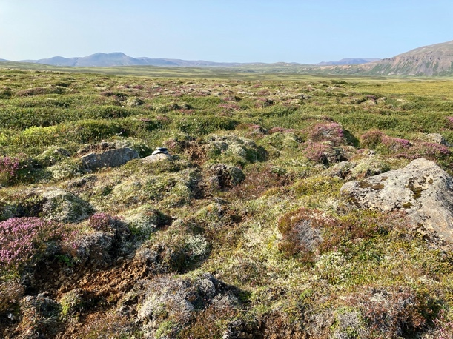
Tundra ecosystems cover a significant portion of the Earth’s surface and are experiencing high rates of change. Rapid warming in tundra biomes has led to well-documented changes in vegetation cover (e.g., ‘shrubification’), geomorphology (e.g., slope failures caused by thawing permafrost) and biogeochemical cycling (e.g., the turnover of nutrients in soils). Climate-driven changes in vegetation cover, geomorphology and biogeochemical cycling are interconnected and synergistic. However, these phenomena are usually studied in isolation and at a single scale (e.g., at a plot or landscape scale).
Figure 1 A tundra landscape in northern Iceland showing small scale variability
Changes in biogeochemical cycling initiated by climate change are particularly significant, as they impact on soil fertility, primary production and carbon storage.

To predict the response of tundra ecosystems to climate change, we need to understand how different components of tundra ecosystems are interlinked. For example, small- and medium-scale topographic controls on vegetation dynamics and biogeochemical cycling are rarely considered, even though there is good evidence that topography on this scale can generate steep environmental gradients in tundra biomes. We also need to understand how plot-scale processes scale-up to landscape-level impacts. Tundra landscapes are inherently patchy and small-scale environmental variation (e.g., the difference between an exposed knoll and a sheltered gulley) can have a big impact on ecological responses to climate change.

Our project therefore aims to understand how vegetation cover, hydrology and geomorphology structure nutrient availability in tundra biomes across different spatial scales (plot to landscape). If we are to quantify nutrient availability at a landscape scale, we need to know how small-scale variations in topography and vegetation cover combine and scale-up to influence the availability of key nutrients, specifically nitrogen (N) and phosphorus (P).

Objectives and methodologies

This project addresses the following questions:
1. How do metre-scale topography, hydrology and vegetation cover in the tundra biome interact to control nutrient availability?
2. Can we use a combination of remote sensing imagery and plot-scale measurements to quantify tundra nutrient availability on a large- (landscape-) scale?

The project will be conducted in northern Iceland, a sub-Arctic location that is experiencing rapid climate change and ongoing soil degradation. We may also compare this site with a Scottish upland location which is experiencing ‘shrubificaiton’ and vegetation change. We will deploy field surveys, laboratory techniques and the analysis of remote sensing imagery.

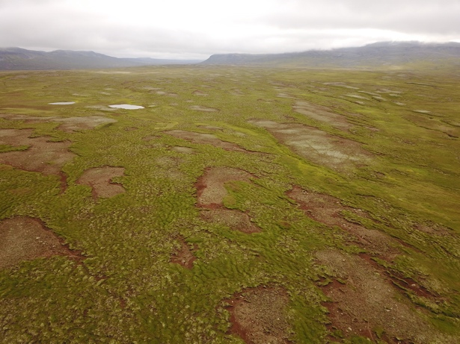
The core of the project will involve long-term (12+ months) monitoring of nutrient availability using an array of plant root stimulator (PRS) probes. These innovative devices have the potential to deliver accurate, field-based measurements of nutrient availability in a way not achievable by conventional methods. We will design a factorial experiment to collect replicated soil nutrient measurements encompassing contrasting vegetation types and topographic situations. Measurements made with the PRS probes will be compared with metrics of nutrient availability obtained by conventional (lab-based) methods, for calibration. We will also conduct high-resolution surveys of the study area using a multispectral sensor mounted on a drone, to collect data on topography, surface vegetation cover and plant vitality (e.g. NDVI and other metrics).
Figure 2 Drone image of large-scale erosion patches in northern Iceland

The measurements of nutrient availability in different settings will then be combined with the high-resolution remote sensing imagery (from drones and satellites) to model nutrient availability at a landscape scale. From this data we can then assess the extent to which topographic drivers of nutrient availability could be modelled from more widely available topographic and vegetation cover datasets (e.g. LIDAR data). This upscaling will provide insights into the spatial heterogeneity in nutrient availability at landscape scales and provide estimates of vegetation cover, topography and nutrient availability at resolutions commensurate with satellite observations (e.g., 3-30 m).

The student will design the field experiment; conduct field surveys in Iceland (including vegetation survey and soil sampling); analyse soil samples in the laboratory and acquire and analyse remote sensing imagery (from both drones and satellites). The project will include field seasons Iceland. Training will be provided in experimental design and statistical analysis; field measurement of nutrient availability; plant community and soil analysis, acquisition and analysis of remote sensing data by drone and in spatial modelling.
Funding justification
Total RTSG funding request £5972
Fieldwork in Iceland x 2 (to set up and retrieve PGS loggers) £3340 – 4 x return flights (£300), car hire, subsistence and accommodation @£110/day
Attendance at EGU, Vienna = £940 (return airfare Edinburgh-Vienna @ £400; accommodation & subsistence for four days @ £110/day; registration fee @ £100) Plant Root Simulator sensors and analysis £1575 (36 sensors @ £47 each including analysis)

